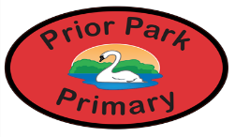
Prior Park Primary Medium Planning: Early Years Class Spring Term First Half Term 2026
Literacy
Children will be learning to:-
Use letter sound knowledge to read and write words (Fred Talk)
Learn to read and write some tricky words (said, the, I, to, go, me and no)
Begin to use punctuation correctly (full stop, space)

Personal Social Emotional Development
Children will be learning to:-
Be confident to try new activities
Understand that they can make a difference (working together, responsibility, caring)
Identify how they can care for their home, school and special people (look after, help)

Physical Development
Children will be learning to:-
Develop motor skills through movement with music (Squiggle)
Develop body awareness by exploring how different body parts move and stretch
Practice balance and coordination using simple poses (tree, butterfly, frog etc)
Build strength and flexibility through yoga stories.

Communication and Language
Children will be learning to:-
Listen to others in conversation and respond appropriately
Use talk and new vocabulary in role play
Listen to stories and respond to comments, questions and articulate their thoughts
Give and follow simple instructions as part of practical games
Use talk to help work out problems and organise thinking

Mathematics
Children will be learning to:-
Understand the concept of zero.
Understand the composition of numbers up to 5
Explore and make different representations of 6, 7 and 8.
Develop an understanding of the concept ‘1 more and 1 less’ from 0-8 (more, less)
Measure and compare masses and capacities (mass, weight, balance, same as, heavier, full, empty, half full, nearly empty, nearly full, how much, quantity, measure, fill )
Develop an understanding of doubling (double)
Explore, compare and use the vocabulary linked to length (long, short, same as, shorter, longer)

Expressive Arts and Design
Children will be learning to:-
Sing familiar rhymes and songs
Use marbling inks to create pictures
Use their imagination during story based yoga stories

Animals

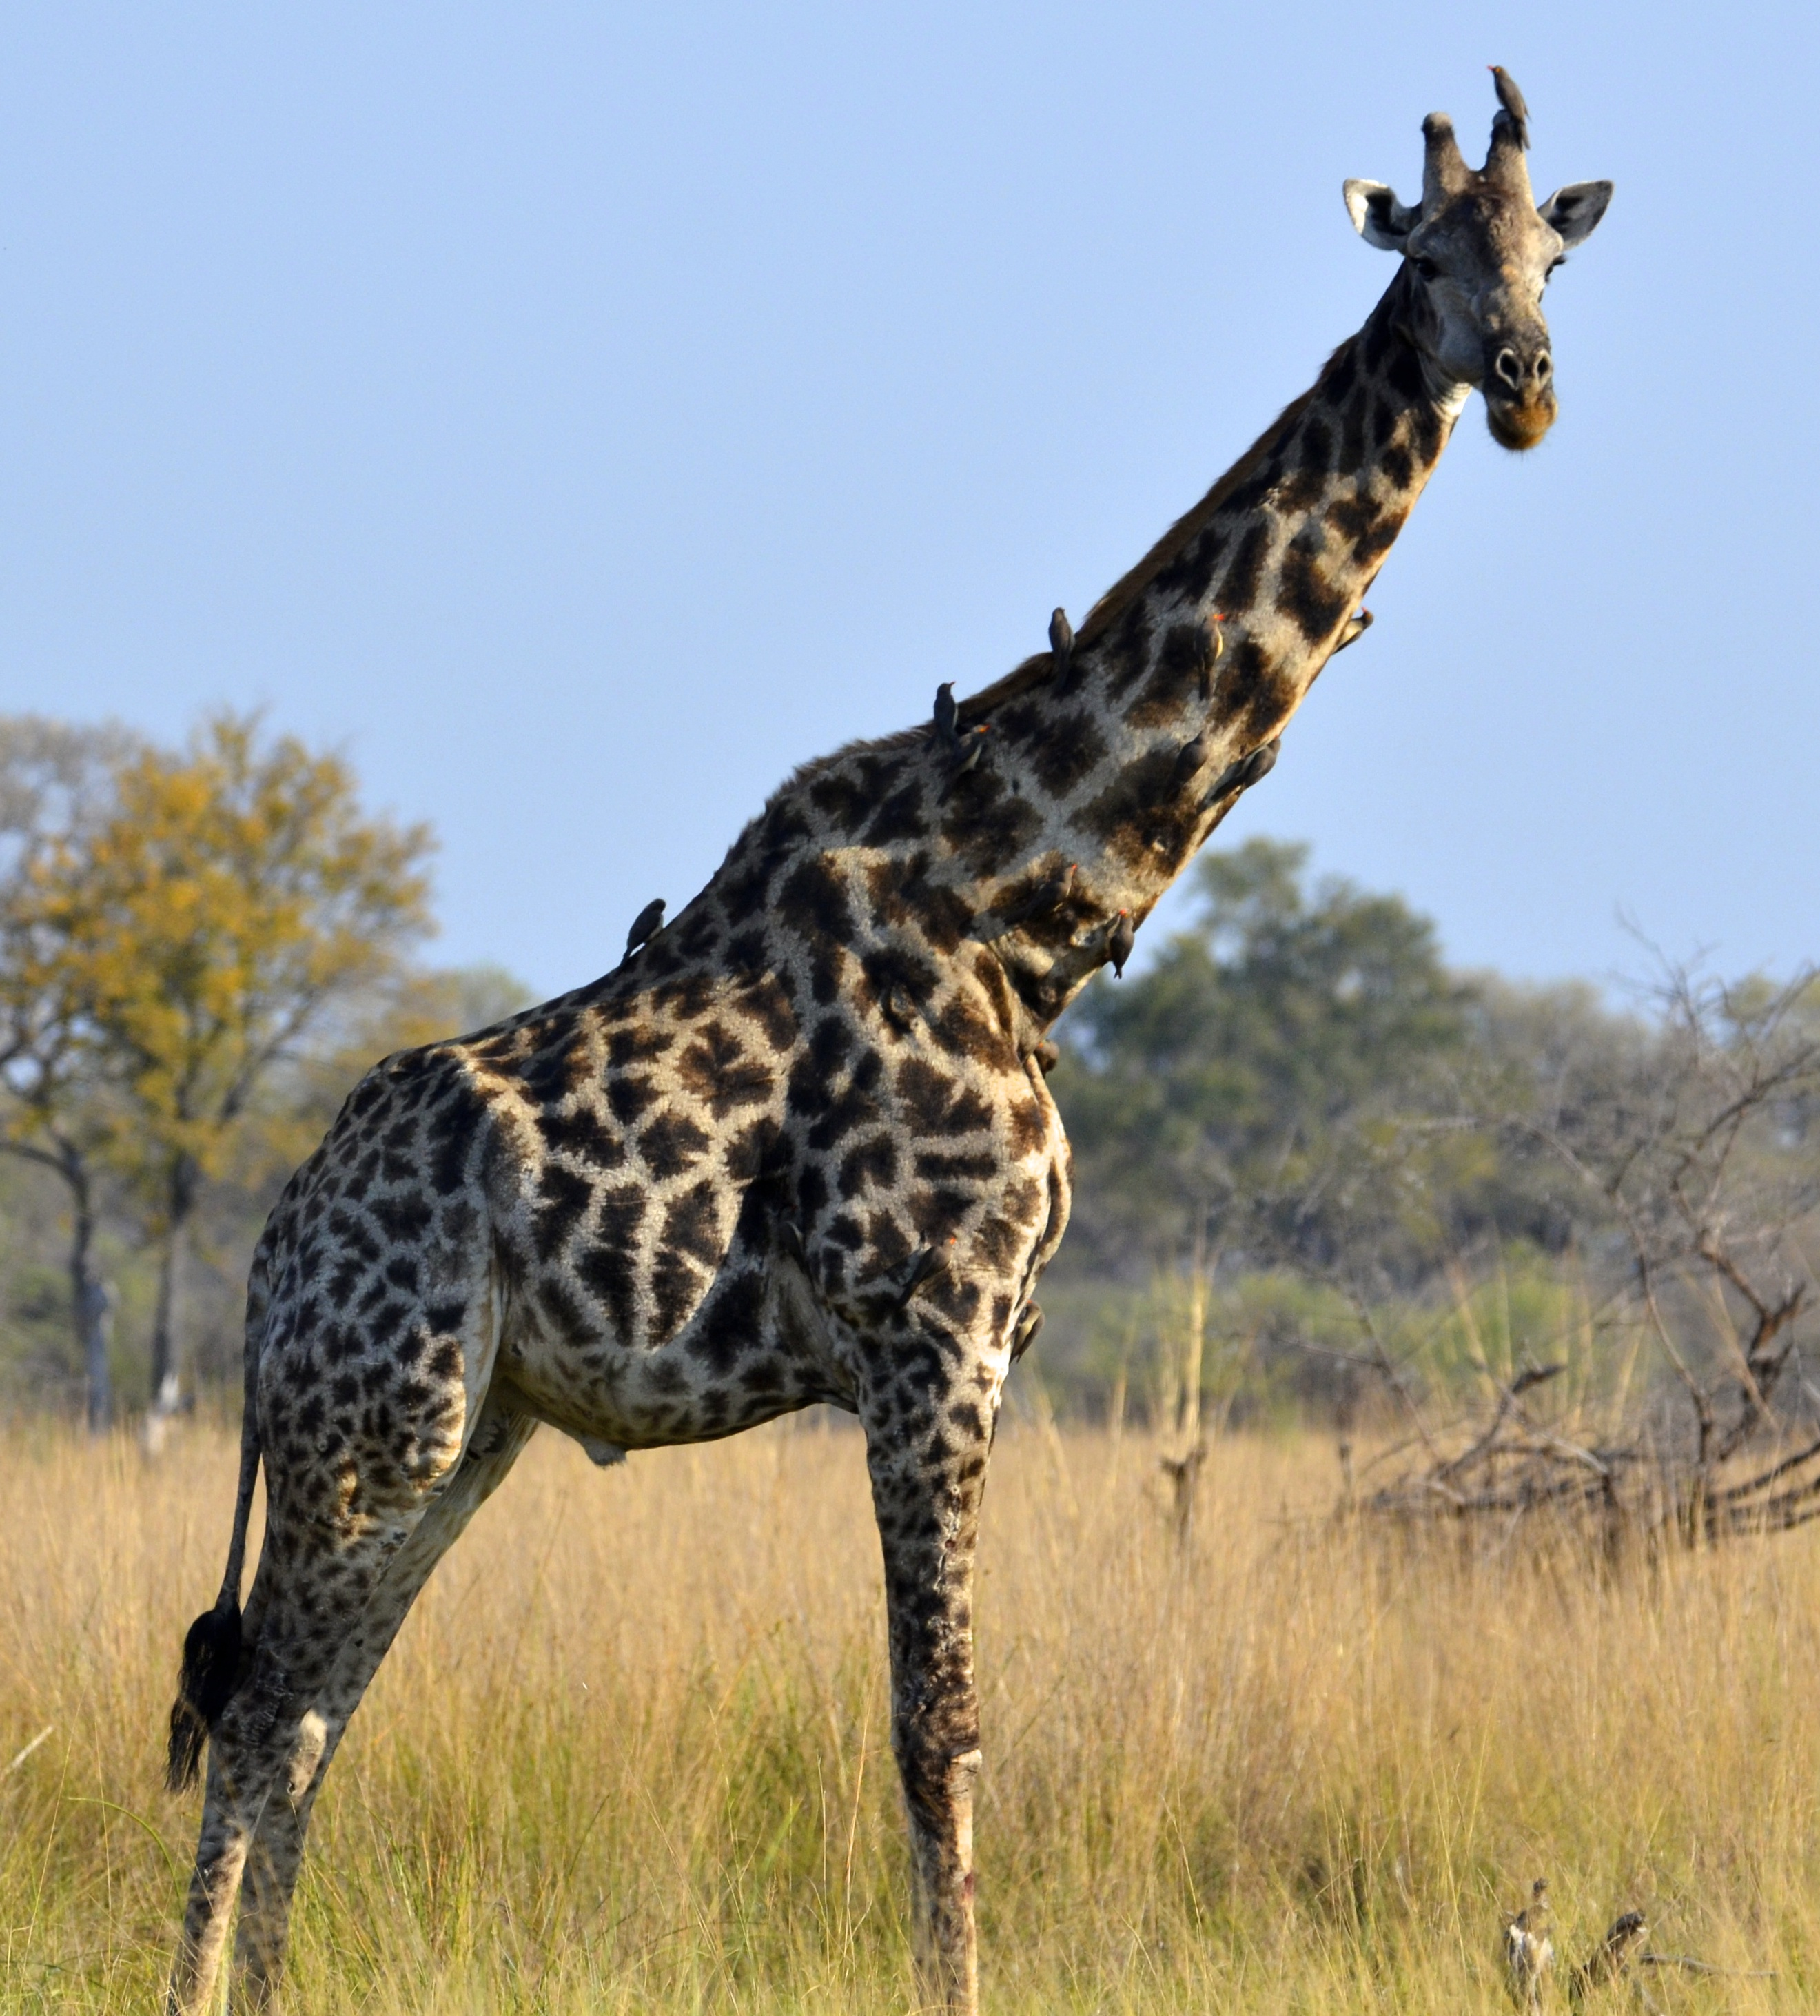

Understanding the World
Children will be learning to:-
Sort objects into living and non-living (alive, grow. move, non-living, sort, group)
Sort animals based on where they live (farm, desert, polar, woodland, jungle)
Identify, describe and name garden birds (blackbird, robin, starling, crow, sparrow, pigeon, chaffinch, wing, beak, claws)
Develop an understanding of Helen Sharman (astronaut, rocket, space)
Investigate life on Earth and in space (planets, earth, gravity, space station, space, rocket)

